ALBERTA BAND ASSOCIATION PROVINCIAL FESTIVAL OF BANDS 2019
Dear Band Director:
Enclosed please find your director’s package for the 2019 Alberta Band Association Provincial Festival of Bands. Once again, this year’s event promises to be exciting and educational for both you and your students, with bands participating in performances, clinics, and sight-reading activities.

If you want to check your band’s performance time, go to the Alberta Band Association website at www.albertabandassociation.com . The performance schedule is updated weekly.
Please read the attached director’s guide.

To get to Red Deer College, from Queen Elizabeth Hwy 2, take the 32nd Street exit (see attached map). Take your first right hand turn (College Circle), and you will see the Arts Centre (two story brick building). You can unload at the north-west doors of the Arts Centre. Please do not leave buses running.

Should you have any questions while at Red Deer College, please ask one of our technical staff (they will be wearing A.B.A. Provincial Festival of Bands nametags).

Below are a few suggestions that will keep the festival running smoothly:
- Please ensure that your students DO NOT leave personal valuables, money, etc. in the equipment storage area (Studio D). We are unable to provide security for this area.

- There are dressing rooms reserved in the Arts Centre for those students needing them. Please check at the Registration Desk for their location.

- You and your band are encouraged to listen to other bands performing at the festival, but there is no food, drink, or flash photography allowed in the Main Theatre or in the studios. Please respect the performances of other bands and do not enter the theatre during a performance.

- Because there are other activities in the Arts Centre, we would appreciate as much quiet in the hallways as possible.

5. There is a cafeteria and food kiosks on campus.

- Should you encounter any travel problems during the festival that might mean you will be delayed for your performance, you can leave a message with Joyce Howdle- Coordinator for the Festival of Bands cell phone: 403-341-0762.

- Please label your equipment and music with your school/band name.

- Should you have any questions or concerns, please feel free to contact Joyce Howdle at (403) 342-3526 or email at joyce.howdle@rdc.ab.ca.

Have a great festival!

ALBERTA BAND ASSOCIATION PROVINCIAL FESTIVAL OF BANDS 2019
Director’s Guide Please Read Carefully
Upon arrival at Red Deer College Arts Centre (north west doors) please check in and have your scores (in order of performance) ready to hand in.

Photographs - If you do not intend to have any pictures taken, please indicate this to your guide.

Images Unlimited is the official photographer for the festival. Please make arrangements directly with them at info@imagesunlimited.ca or phone 403-253-0200.

  - Equipment Room– Arts Centre Studio D – Please do not leave personal valuables in this room.

  - Warm-Up – Arts Centre Studio A
30 min. before performance time – Week I
40 min. before performance time – Wed., Fri. and Sat. – Week II

There will be an “Alberta Band Association Provincial Festival of Bands” guide to take you from the warm-up area to the performance area.

  - Performance – Arts Centre Mainstage
30 min. – Week I
40 min. – Wed, Fri and Sat- Week II

Your performance will be recorded on 2 channels – 1 channel will be the performance and the second will be the adjudicator’s comments. If you want to listen to the performance only, adjust the levels on your device. Your performance will be shared with you through Dropbox.

Your guide will escort you to the performance area. Each band is encouraged to play an unadjudicated warm-up chorale or scale before you are introduced to the audience. Total stage time must not exceed 30 minutes for a band performing in Week I and 40 minutes for a band performing in Week II (Wednesday & Friday). Each participating band must provide the adjudicators with three conductors’ scores for all non-syllabus (own choice) selections. Please ensure that all measures are numbered. The Alberta Band Association will supply conductors’ scores for all syllabus selections.

Please note: it is against copyright laws to photocopy music. Complete the enclosed performance order sheet with the selections (in order) your band will be performing, the seating plan and any other information to be used in introducing your band and scan and email them prior to the festival so our technicians are prepared for your band’s performance.

To receive a rating each band must perform three selections (one of which is from the syllabus) and participate in all facets of the festival: performance, clinic, sight-reading/fundamentals.

Please Note: Chairs, stands, bass drum, 4 timpani, chimes, xylophone, vibraphone, marimba, gong, suspended cymbal, and orchestra bells will be provided for your use on stage. There will also be an acoustic piano, a drum set and a bass amp in the stage wings for those bands requiring one.

Each band is to provide its own snare drum, cymbals, beaters, mallets and sticks and auxiliary percussion.

After your performance you will be escorted to your clinic room.

  - Clinic - Arts Centre Studio B/C
30 min. – Week I Bands
40 min. – Wednesday/Friday/Saturday- Week II Bands

In addition to each band being rated on its performance and on the sight reading/fundamentals portion of the festival, the clinic session will also be rated. Once you are finished your clinic session, you will begin the Sight-Reading/Fundamentals portion of the festival.

  - Sight-Reading – Arts Centre Studio B/C
30 minutes – Week I Bands
40 minutes – Wednesday/Friday/Saturday Week II Bands
A separate adjudicator will rate the sight-reading portion of the festival. Each band (Level II-VI) will be given a selection two pieces provided by the festival one grade level below the class entered. Bands will be given five minutes (Level II & III) or eight minutes (Level IV-VI) to study the director’s choice before performing the selection. Sight-reading will not be open to public viewing, but open to the band’s entourage at the discretion of the band director.

Fundamentals Clinic – Grade I Bands only
The Alberta Band Association recognizes that playing, listening, reading, creating and valuing are important considerations in the school music curriculum.

The clinic will proceed as follows:
- Perform the chorale designated by the Alberta Band Association for the fundamentals clinic (score and parts are available at the Alberta Band Association website by the end of January). The performance of the chorale will be adjudicated using the same evaluation criteria as the main stage performance.
- Play three major scales in concert Bb, Eb and F major, up and down in quarter notes without repeating the top note, M.M. quarter note = 120. One scale will be tongued, one scale slurred two-tongued two, one scale slurred. Percussionists are to perform these scales on mallet instruments.
- Echo on instruments a five-note melody. The melody will be a maximum of 2 bars, based on the first five notes of the concert Bb major scale, starting and ending on the tonic in 4/4 time. This melody will be administered by the adjudicator.
- Clap a rhythmic pattern, a maximum of 2 measures in length, while counting the beat and subdivision out loud (e.g. 1&2&3&4&). The pattern will be written in either 4/4 or ¾, will include combinations of half, quarter and paired eighth notes and quarter rests. Rhythmic patterns will be administered by the adjudicator.

Once you have completed the sight-reading or fundamentals session you are encouraged to listen to other groups perform in the Main Theatre of the Arts Centre. Please NO food, drinks or flash photography in the theatre. Groups are asked to sit below the adjudicators table and not behind or above the adjudicators.

The equipment storage area is in Studio D of the Arts Centre.

Total time for warm-up, performance, clinic and sight-reading or fundamentals is:

    - 2 hours (Week I Bands)
    - 2.75 hours (Wednesday/Friday/Saturday - Week II Bands)

Red Deer College cafeteria and food kiosks will be open during the festival. Please ask for directions at the A.B.A. registration desk. For special arrangements please contact the RDC cafeteria directly at Chartwells.foodorders@rdc.ab.ca.

HAVE A GREAT FESTIVAL!

ALBERTA BAND ASSOCIATION PROVINCIAL FESTIVAL OF BANDS 2019
Performance Order
(Please print clearly)

Performance Date:

Performance Time:

Ensemble Name:

Director Name:

School Principal Name:

Grade Level Entered:

Selection #1: Composer:

Selection #2: Composer:

Selection #3 Composer:

Information to be included when introducing your group to the audience and adjudicators – include how many years of study; school population, etc.: Please PRINT Clearly

Please complete and scan and email as soon as possible to: Alberta Band Association Provincial Festival of Bands 2019 ATTN: Joyce Howdle – joyce.howdle@rdc.ab.ca

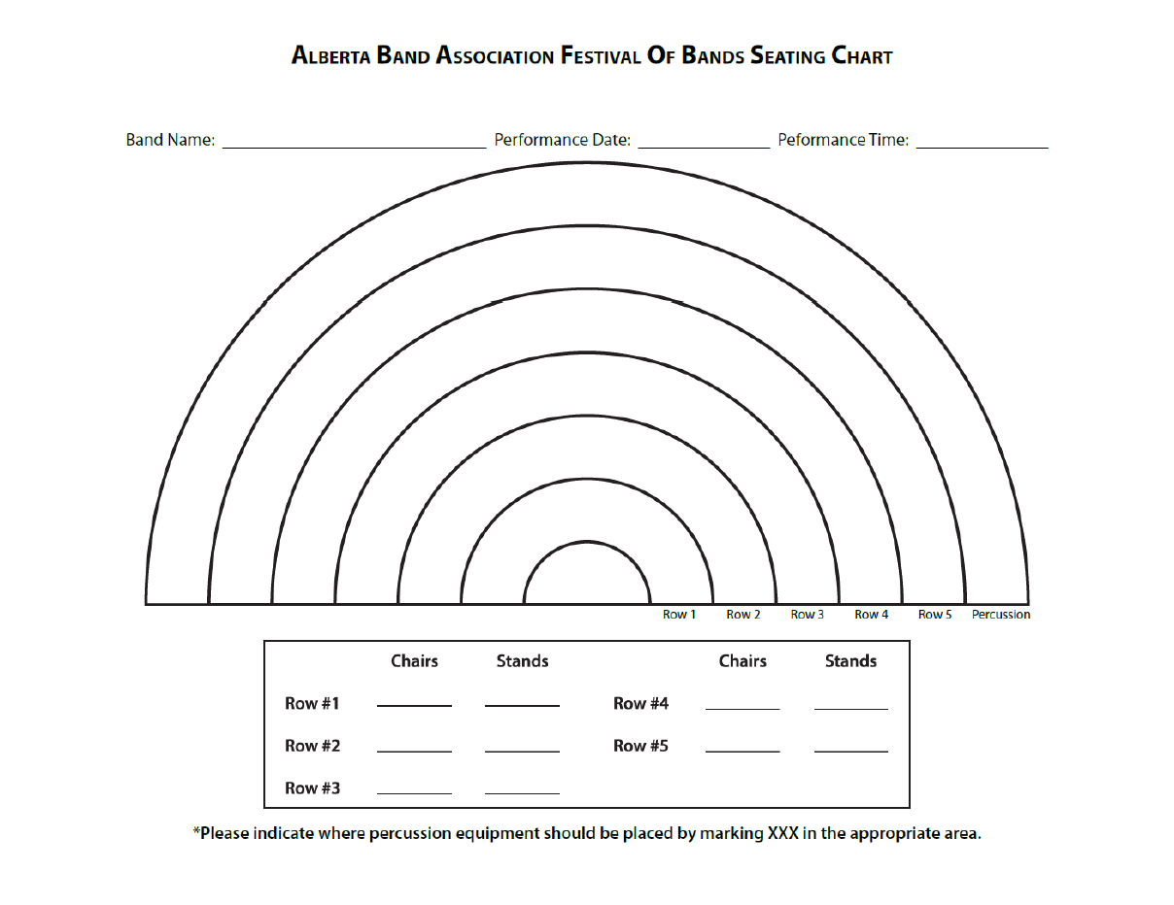

Why Sight Read?

Music Sight Reading
Presented by Dr. Tom Dust
Secondary Education, University of Alberta

• Groups that sight read will have more rehearsal time for working on balance, blend, etc.
•Good sight reading enables ensembles to explore a greater body of literature
•Good sight readers develop new musical understandings
•Sight reading is an essential skill for many musicians working in ensemble situations

Research on Sight Reading Rhythmic Factors
Most reading errors are rhythmic reading errors Rhythmic training improves sight reading ability
Bands showing the most improvement in read ability followed an approach that included:
- recognizing the beat
- clapping rhythm patterns while keeping the beat with the foot
- playing rhythm patterns on one note while keeping the beat with the foot

Visual Factors
• Skilled readers look ahead while holding “long” notes
•Skilled readers have a visual field of about seven notes
•Skilled readers use significantly more eye fixations than poor readers use
•Skilled readers fixate at a faster rate than poor readers
•Skilled readers see more in each fixation

Cognitive Factors
• Skilled readers “chunk” material
•Skilled readers are not reliant upon an instrument
•Skilled readers understand and can articulate their reading process
•The development of “audiation” is linked to improved reading skills
•Changes in reading skills suggest new levels of musical understanding

Other Factors
• Students can identify more reading errors when listening to recordings of their performances than when actually performing
•Good sight readers are faster than poor sight readers at matching notes to note names
•Good sight reading depends on reading notes in relation to other notes
•Good sight reading is correlated with high musical aptitude, high GPA, high math achievement, and high reading achievement
•Music composed of small intervals is more accurately read than music composed of large intervals (study done with pianists)
•The Spacing of notation greatly affects eye movement and processing time
•In one study, Private Instruction combined with Number of Selections Read accounted for the greatest proportion of variance in sight reading scores

Action for Results
• Use a rhythm training program with your ensemble
•Teach musical understanding alongside the development of mechanical skills
•Teach “speed reading” – refer to the work of David Hickman
•Help students develop the ability to “audiate” – singing, chanting, moving, listening
•Help students understand the reading process – eye motion, chunking, musical understanding

Red Deer College Residence

Is your band participating in the Alberta Band Association “Provincial Festival of Bands” at Red Deer College, May 13 - 25? Does your group need accommodations? Red Deer College offers accommodation to groups or individuals within the Residences from May to August. These reasonably priced apartments or rowhouses contain kitchens, living rooms, single bedrooms and private bathrooms.

Our Residence units are four-bedroom apartment or rowhouse style of accommodations. All guests will have their own bedroom with a locking door. Each bedroom contains a single bed, desk and chair. Linens and towels can be provided or your group may choose to bring their own sleeping bags. The living rooms have couches, chairs, coffee tables and end tables. The kitchens have a refrigerator and stove although dishes and cooking utensils are not provided. The apartments have one bathroom to be shared by the roommates while the rowhouses have up to two bathrooms.

Please contact the Residence Office at (403) 342-3257 to make a reservation or for information on cost and availability.

